Wahoo Website Archive

August 2018

PROJECT OVERVIEW

PHASE 1 TIMELINE
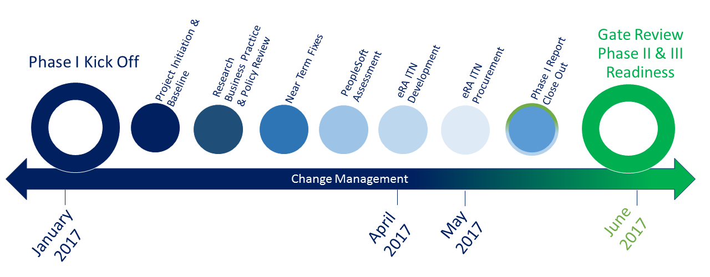

Phase 1 Scope
Research Administration, Pre & Post Award Accounting business process review and design for industry best practices implementation
- Research Business Practice and Policy Review Assessment – Documentation review, interviews, research operations walk through, integrated review of Pre-Award, Post-Award and Grants Accounting, review of current state and To Be future state in policies, processes and procedures, Organizational structure review and analysis
- Electronic Research Administration (eRA) RFP development and Vendor Selection
- UCF Financials / PeopleSoft Environment Review and Assessment for Grants Implementation and Optimization
- Change Management Planning for Organizational & Technology Change

Phase 2 Scope
- Implement PeopleSoft Grants Post Award Module
- Change Management
- Training initiatives

Phase 3 Scope
- eRA System Implementation and PeopleSoft integration
- Change Management
- Training initiatives

ANNOUNCEMENTS

PROJECT WAHOO VENDOR DEMOS

INTRODUCTION:
UCF is currently undertaking a multi-year, multi-phased project focused on the University-wide restructuring of research administration business processes and technologies to support Principal Investigators (PI) and UCF’s research enterprise. As part of Phase II of this project, we will begin reviewing electronic research administration (eRA) system vendor proposals and will be soliciting your participation in vendor system demonstrations.
Details on the ITN 1628JCSA are available here.

VENDOR DEMOS ARE SCHEDULED FOR THE FOLLOWING DATES AND TIMES:

Huron Consulting Services, LLC
8/15/2017 01:00 PM
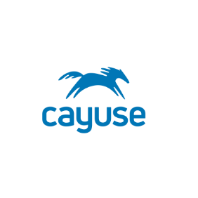 | Cayuse, Inc  8/16/2017 08:30 AM
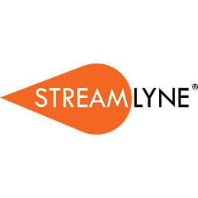 | Streamlyne  8/16/2017 01:00 PM

LIVE STREAMING:
Live video streaming of the sessions will be made available here.

SURVEY:
We kindly invite you to attend the sessions and provide your feedback using the short Qualtrics survey here.
Your participation in the selection process will be crucial to choosing an eRA system that best meets the needs of UCF research community and supports UCF on achieving our strategic goals.

